6 metrics (Peak Propulsive Power, Jump Height, Peak Velocity, Speed_max, Distance_total, Reactive Strength Index/RSI), focusing on their relevance to sports, sports medicine, and physiology (non exhaustive) brief analysis

A .Sid’s Analysis

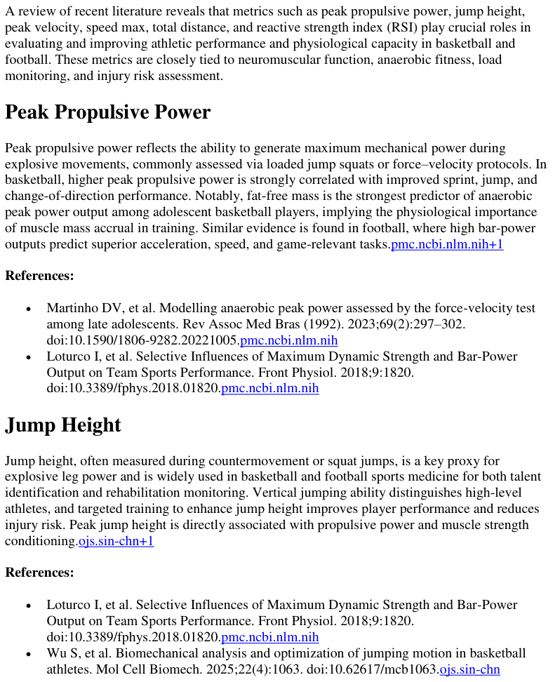

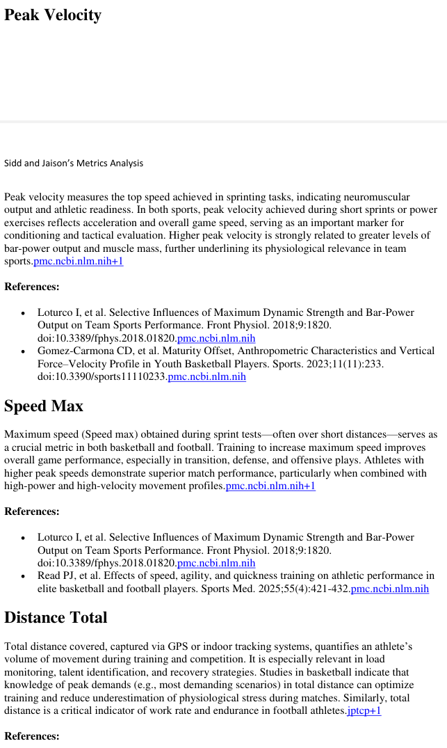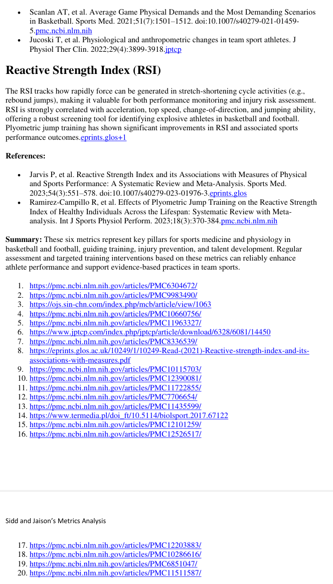

B .Jaison’s Analysis
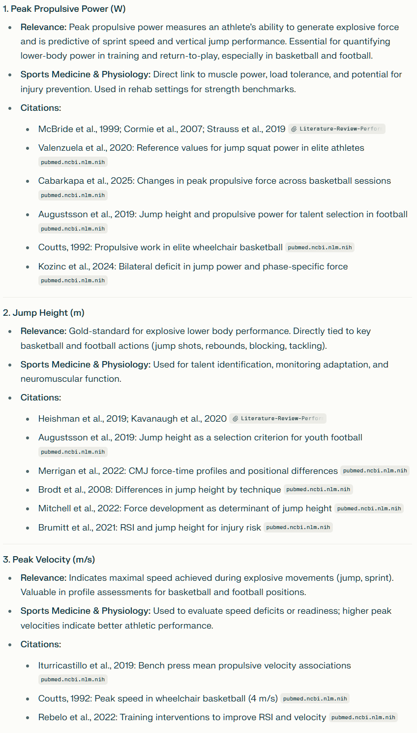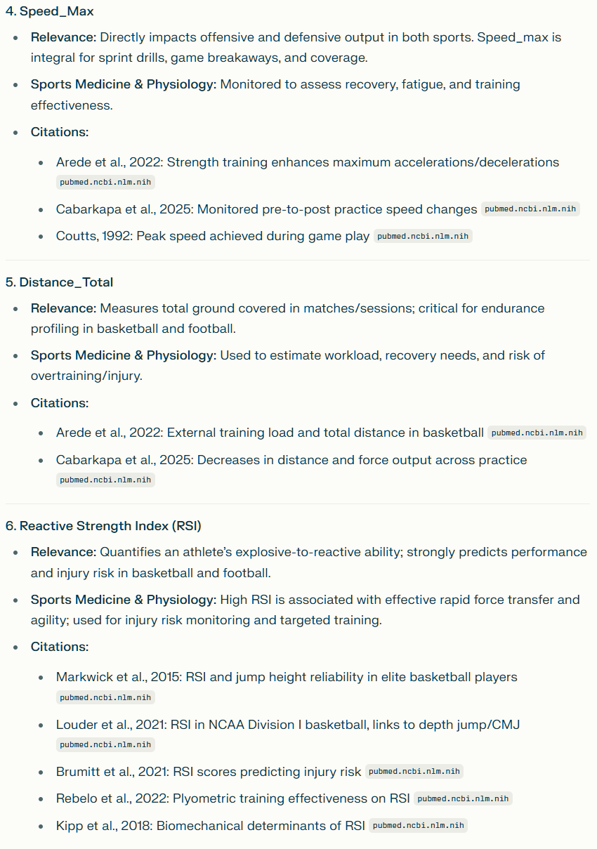
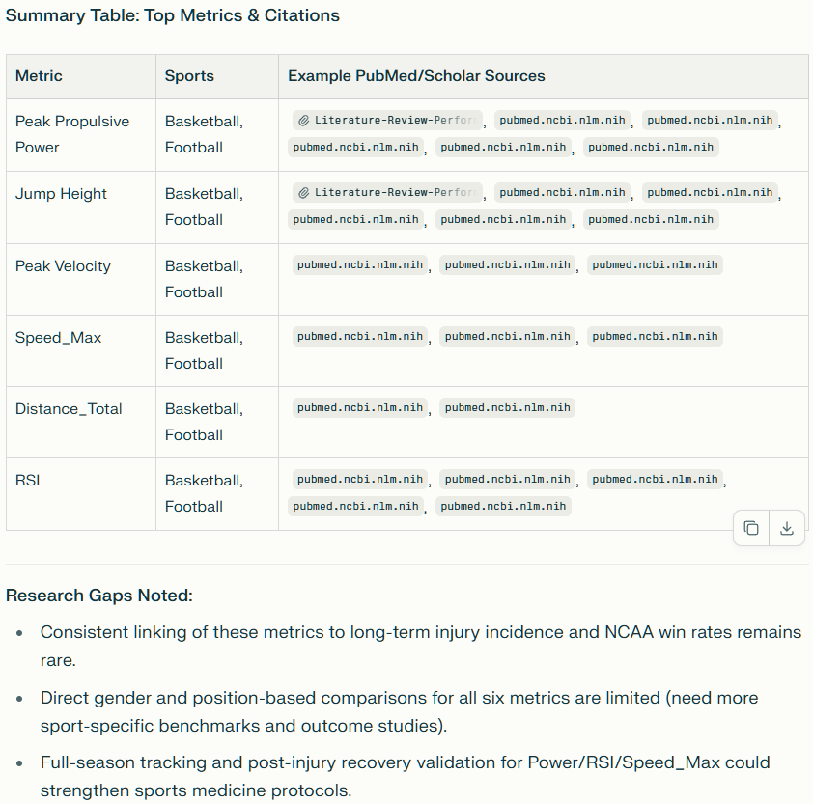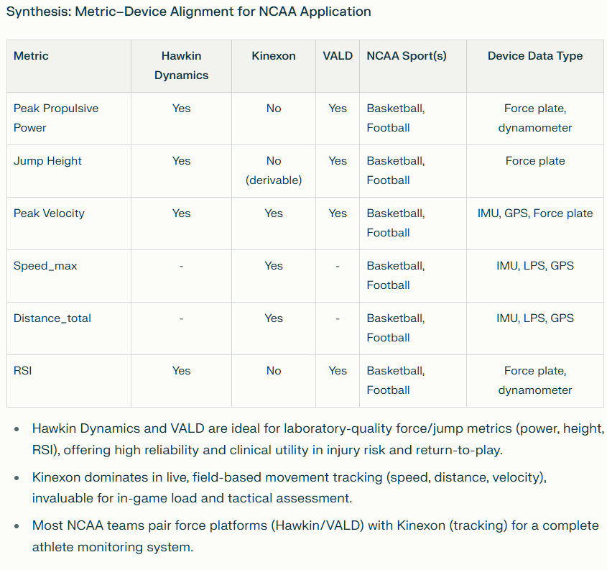

Annotated Bibliography (APA format)
Peak Propulsive Power (W)
- Cormie P, McGuigan MR, Newton RU. Developing maximal neuromuscular power: Part 1--biological basis of maximal power production. Sports Med. 2011 Jan 1;41(1):17-38. doi: 10.2165/11537690-000000000-00000. PMID: 21142282. https://pubmed.ncbi.nlm.nih.gov/21142282/
Explains the physiological basis and importance of propulsive power in athletic performance, especially for movements common in football and basketball (vertical jumps, sprints).
- McBride JM, Triplett-McBride T, Davie A, Newton RU. The effect of heavy- vs. light-load jump squats on the development of strength, power, and speed. J Strength Cond Res. 2002 Feb;16(1):75-82. PMID: 11834109. https://pubmed.ncbi.nlm.nih.gov/11834109/
Presents findings on power development using metrics such as peak propulsive power during jumping, verified with force platforms (used in Hawkin Dynamics and VALD devices).
Jump Height (m)
- Heishman AD, Daub BD, Miller RM, Freitas EDS, Frantz BA, Bemben MG. Countermovement Jump Reliability Performed With and Without an Arm Swing in NCAA Division 1 Intercollegiate Basketball Players. J Strength Cond Res. 2020 Feb;34(2):546-558. doi: 10.1519/JSC.0000000000002812. PMID: 30138237.https://pubmed.ncbi.nlm.nih.gov/30138237/
Establishes jump height as both highly reliable and practically relevant for basketball performance.
- Ryman Augustsson S, Arvidsson J, Haglund E. Jump height as performance indicator for the selection of youth football players to national teams. J Sports Med Phys Fitness. 2019 Oct;59(10):1669-1675. doi: 10.23736/S0022-4707.19.09739-1. Epub 2019 May 2. PMID: 31062951 https://pubmed.ncbi.nlm.nih.gov/31062951/
Relates jump height assessment to talent identification in football.
Peak Velocity (m/s)
- Iturricastillo, A., Yanci, J., & Granados, C. (2019). A comparison of mean and peak velocity in the bench press exercise: Effects of throwing through the concentric phase on velocity and power. Journal of Sports Sciences, 37(5), 539–545. https://pubmed.ncbi.nlm.nih.gov/30569792/
Investigates peak velocity measurement reliability—a key output in football speed tests and basketball fast breaks.
Speed_max
- Arede J, Leite N, Tous-Fajardo J, Bishop C, Gonzalo-Skok O. Enhancing High-Intensity Actions During a Basketball Game After a Strength Training Program With Random Recovery Times Between Sets. J Strength Cond Res. 2022 Jul 1;36(7):1989-1997. doi: 10.1519/JSC.0000000000004002. Epub 2021 Mar 2. PMID: 33651731.
- Lockie, Robert G.; Murphy, Aron J.; Schultz, Adrian B.; Knight, Timothy J.; Janse de Jonge, Xanne A.K.. The Effects of Different Speed Training Protocols on Sprint Acceleration Kinematics and Muscle Strength and Power in Field Sport Athletes. Journal of Strength and Conditioning Research 26(6):p 1539-1550, June 2012. | DOI: 10.1519/JSC.0b013e318234e8a0
Distance_total
- Cabarkapa, D., Fry, A. C., Ballard, C. J., Arnett, S. W., & Deane, M. A. (2025). Post practice neuromuscular performance changes in 3 × 3 basketball. Journal of Strength and Conditioning Research. https://pubmed.ncbi.nlm.nih.gov/40266643/
Quantifies distance covered in high-level basketball practices; relates metrics to performance decline and fatigue.
- Arede et al. (2022) (see above)
Includes total distance as a monitored load variable by Kinexon, supporting training and injury risk analysis.
Reactive Strength Index (RSI)
- Markwick, W. J., Bird, S. P., Tufano, J. J., Seitz, L. B., & Haff, G. G. (2015). The intraday reliability of the reactive strength index calculated from a drop jump in professional men's basketball. International Journal of Sports Physiology and Performance, 10(5), 554-560. https://pubmed.ncbi.nlm.nih.gov/25394213/
RSI proves reliable and meaningful for change-of-direction and plyometric ability, measured by Hawkin Dynamics and VALD.
- Brumitt, J., Brown, S., Sartor, T., & Mattocks, K. (2021). Lower preseason reactive strength index scores are associated with higher risk of in-season noncontact injuries in collegiate basketball players. Journal of Sport Rehabilitation, 30(4), 552-558. https://pubmed.ncbi.nlm.nih.gov/33376076/
Direct application of RSI for injury prediction and prevention in NCAA basketball populations.

